Expt No:  09(a) | SINGLE ACTING PNEUMATIC CYLINDER OPERATION
Date:
/ /2025

- AIM:
To develop ladder logic for single acting pneumatic cylinder operation using PLC.

- APPARATUS REQUIRED:
- SIEMENS PLC Trainer kit.
- Personal Computer [PC].
- GxWorks3 Software Installed.
- Ethernet cable.

- PROCEDURE:
- Load the Software to the PC.
- Open the Software.
- Switch ON the PLC Trainer.
- Open the New folder and draw the ladder logic program.
- Connect the PLC to PC.
- Select the correct hardware Configuration [Sl. No].
- Store the Program to PLC.
- Run the Program.
- Verify the performance of single acting pneumatic cylinder operation.

- PROBLEM STATEMENT:
Design and demonstrate the operation of a single-acting pneumatic cylinder controlled by two push buttons (PB1 and PB2). The system should function as follows:
- PB1 will initiate the operation of the cylinder (extend it).
- PB2 will stop the operation, causing the cylinder to retract.
The objective of this experiment is to demonstrate the control logic for the pneumatic system, ensuring that the cylinder responds appropriately to the input from the push buttons. Proper sequencing, safety considerations, and functionality of the control system should be verified.

- FLOW DIAGRAM:

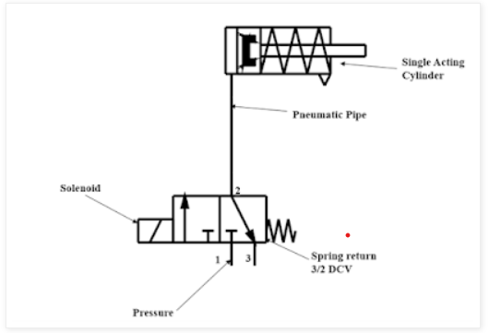

- LADDER DIAGRAM:

- I/O MAPPING:

- RESULT:
Thus, the single acting pneumatic cylinder operation is carried out and verified using SIEMENS PLC.
Expt No:  09(b) | DOUBLE ACTING PNEUMATIC CYLINDER OPERATION
Date:
/ /2025

            - AIM:
To develop ladder logic for double acting pneumatic cylinder operation using PLC.

            - APPARATUS REQUIRED:
- SIEMENS PLC Trainer kit.
- Personal Computer [PC].
- GxWorks3 Software Installed.
- Ethernet cable.

- PROCEDURE:
- Load the Software to the PC.
- Open the Software.
- Switch ON the PLC Trainer.
- Open the New folder and draw the ladder logic program.
- Connect the PLC to PC.
- Select the correct hardware Configuration [Sl. No].
- Store the Program to PLC.
- Run the Program.
- Verify the performance of single acting pneumatic cylinder operation.

- PROBLEM STATEMENT:
Design a control system for a double-acting pneumatic cylinder using two push buttons (PB1 and PB2):
- PB1: Starts the operation by extending the cylinder.
- PB2: Stops the operation by retracting the cylinder.
The objective is to implement a simple control logic that allows for safe and reliable extension and retraction of the cylinder, ensuring correct sequencing and functionality based on user input.

- FLOW DIAGRAM:

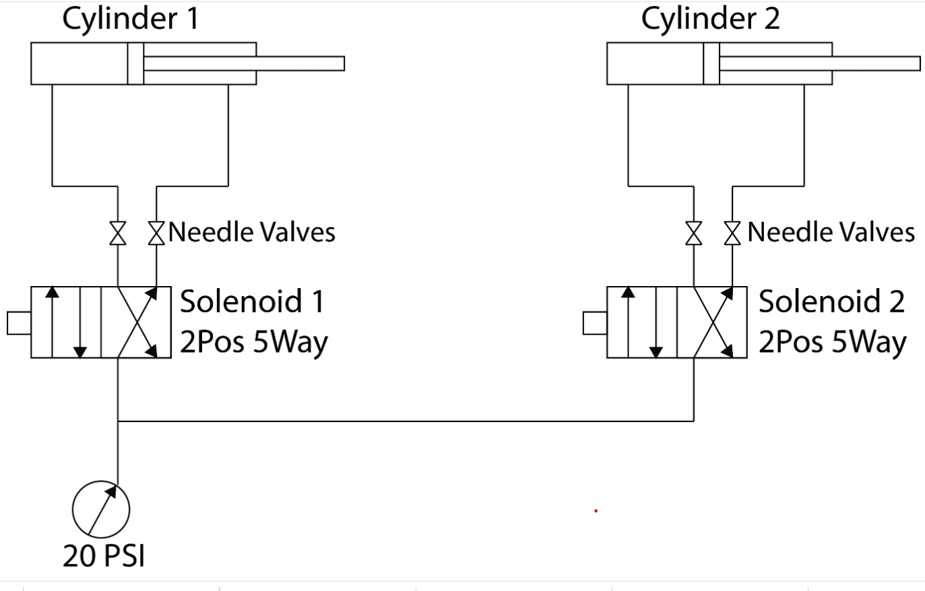
- LADDER DIAGRAM:

- I/O MAPPING:

- RESULT:
Thus, the double acting pneumatic cylinder operation is carried out and verified using SIEMENS PLC.

